**OPENING A COFFEE SHOP IN DENVER**

(Applied Data Science Capstone)

**Introduction**

Let’s say we want to open a nice Coffee Shop in the beautiful city of Denver, Colorado. The problem is finding an appropriate or best location, given there are so many coffee shops and restaurants in and around Denver. This project aims at finding the best locations around/near to which a Coffee Shop can be opened.

**Data Section**

This Project uses FourSquare API to collect location data of different types of places(Cafes, Parks, Offices to name a few) in Denver. The Data consists of geographical coordinates, Name of the place and the category.

**Methodology**

The goal here is to find locations around which opening a coffee shop would be the most profitable. FourSquare API was used to access the location data of various venues in Denver. Five main Parameters were considered

1. Already existing Coffee Shop/Cafes

2. Parks

3. Offices

4. Outdoor Recreational areas other than parks

5. Other Professional places

Presence/Absence of these venues will directly affect the amount of customers coming into the coffee shop. Therefore, directly affecting the Business.

After collecting the data for these places, it was all arranged into one single DataFrame. Then, clusters of similar places were made using Kmeans Clustering Algorithm.

**Result**

After analyzing the clusters, three out of six clusters were eliminated based on the parameters.

Cluster No.3 only had Cafes and opening a coffee shop near such locations would not have been such a good idea. Cluster No.5 only had salons/barbershops, opening a coffee shop there wouldn't have been as profitable[¶](http://localhost:8888/notebooks/CoffeeShop%20in%20Denver.ipynb#Cluster-5-has-only-salons/barbershops,-opening-a-coffee-shop-there-wouldn't-be-as-profitable) Similarly for Cluster No. 6

Therefore, the best places were in Cluster No.1, Cluster No.2 and Cluster No.4(around parks, offices and other areas). Opening a Coffee shop around these places would be a better idea.

These are the locations visualized on the map

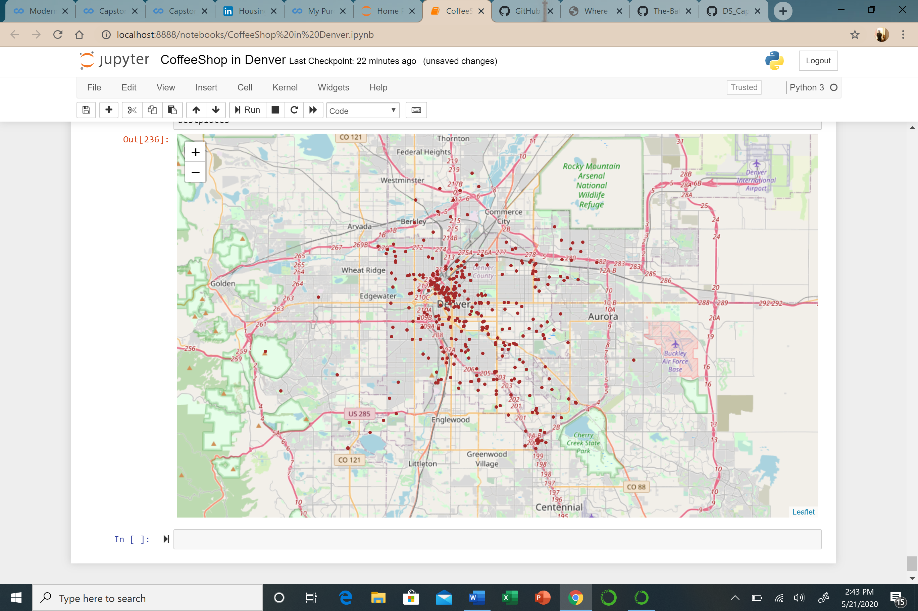

Opening a Coffee Shop around/near these locations would be profitable.

**Conclusion**

Finally, Opening a Coffee Shop near/around locations which has more no. of parks, offices, professional places and less no. of already existing cafes would be profitable. These locations are visualized on the map of Denver above and their geographical coordinates available in a DataFrame.